Association and Sequence Analysis

8.1 Introduction to Association Analysis 8-3
8.2 Interpretation of Association and Sequence Analysis 8-7
8.3 Dissociation Analysis (Self-Study) 8-24

Introduction to Association Analysis
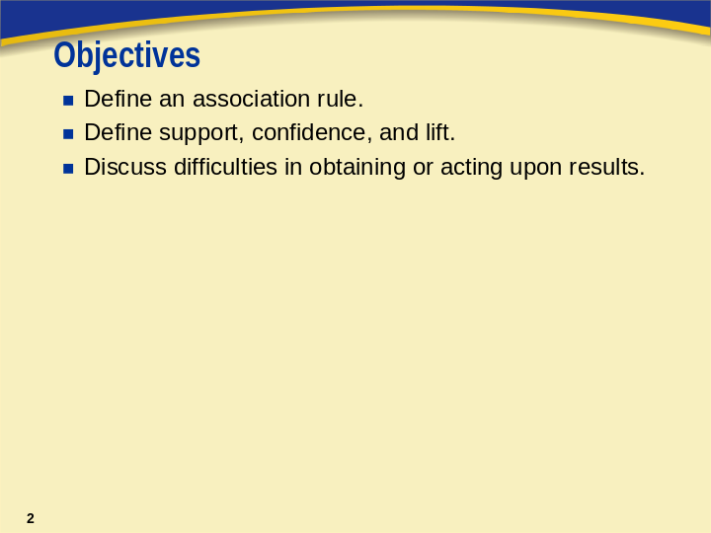
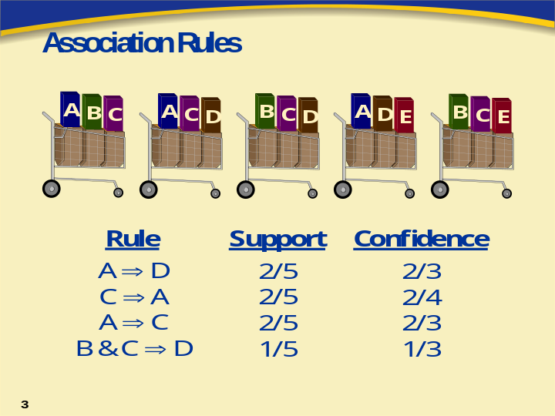
Association rule discovery (aka market-basket analysis, affinity analysis) is a popular data mining method. In the simplest situation, the data consists of two variables: a transaction and an item.
For each transaction, there is a list of items. Typically, a transaction is a single customer purchase and the items are the things that were bought. An association rule is a statement of the form (item set A) ⇒ (item set B).
The aim of the analysis is to determine the strength of all the association rules among a set of items.
The strength of the association is measured by the support and confidence of the rule. The support for the rule A ⇒ B is the probability that the two item sets occur together. The support of the rule A ⇒ B is estimated by
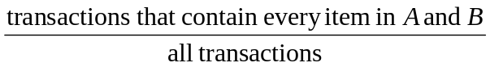.
Note that support is reflexive. That is, the support of the rule A ⇒ B is the same as the support of the rule B ⇒ A.
The confidence of an association rule A ⇒ B is the conditional probability of a transaction containing item set B given that it contains item set A. The confidence is estimated by
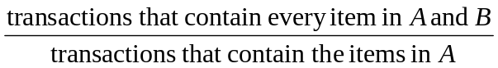.
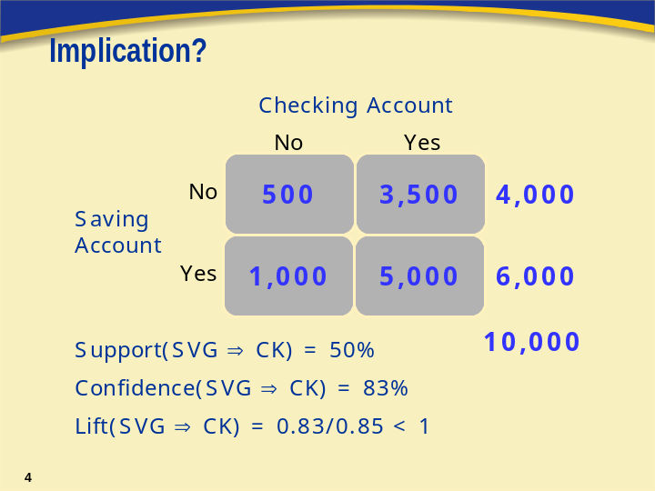
The interpretation of the implication (⇒) in association rules is precarious. High confidence and support does not imply cause and effect. The rule is not necessarily interesting. The two items might not even be correlated. The term confidence is not related to the statistical usage; therefore, there is no repeated sampling interpretation.
Consider the association rule (saving account) ⇒ (checking account). This rule has 50% support (5,000/10,000) and 83% confidence (5,000/6,000). Based on these two measures, this might be considered a strong rule. On the contrary, those without a savings account are even more likely to have a checking account (87.5%). Saving and checking are in fact negatively correlated.
If the two accounts were independent, then knowing that one has a saving account does not help in knowing whether one has a checking account. The expected confidence if the two accounts were independent is 85% (8,500/10,000). This is higher than the confidence of SVG ⇒ CK.
The lift of the rule A ⇒ B is the confidence of the rule divided by the expected confidence, assuming the item sets are independent. The lift can be interpreted as a general measure of association between the two item sets. Values greater than 1 indicate positive correlation; values equal to 1 indicate zero correlation; and values less than 1 indicate negative correlation. Note that lift is reflexive. That is, the lift of the rule A ⇒ B is the same as the lift of the rule B ⇒ A.
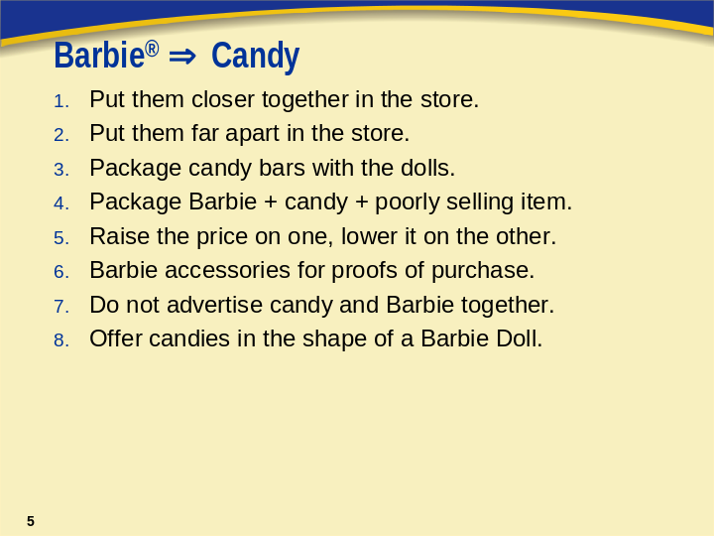
Forbes (Palmeri 1997) reported that a major retailer has determined that customers who buy Barbie dolls have a 60% likelihood of buying one of three types of candy bars. The confidence of the rule Barbie ⇒ candy is 60%. The retailer was unsure what to do with this nugget. The online newsletter Knowledge Discovery Nuggets invited suggestions (Piatesky-Shapiro 1998).
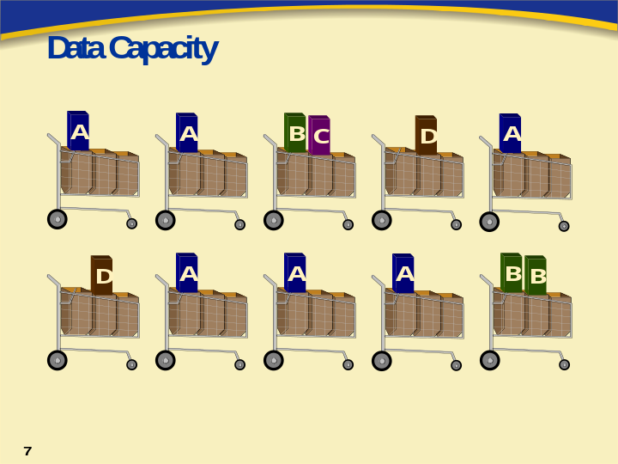
In data mining, the data is not generated to meet the objectives of the analysis. It must be determined whether the data, as it exists, has the capacity to meet the objectives. For example, quantifying affinities among related items would be pointless if very few transactions involved multiple items. Therefore, it is important to do some initial examination of the data before attempting to do association analysis.

Interpretation of Association and Sequence Analysis
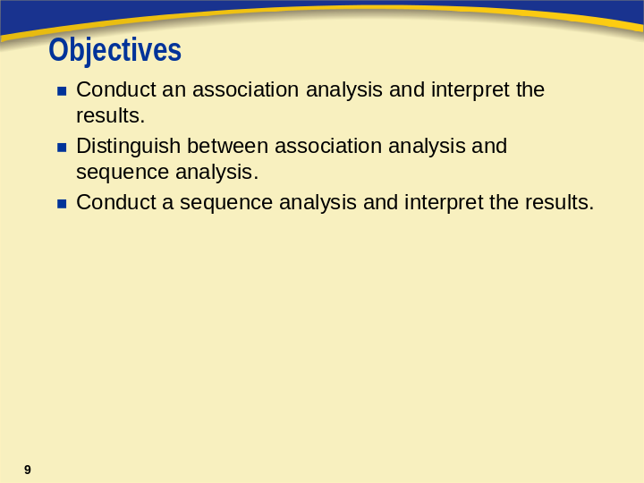
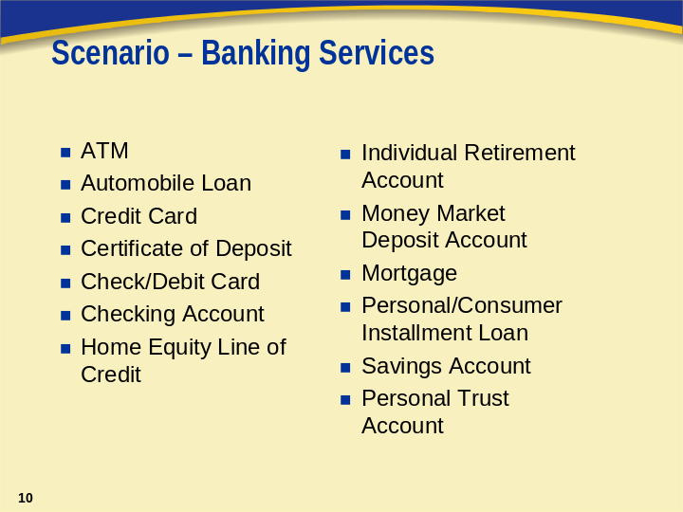
A bank wants to examine its customer base and understand which of its products individual customers own in combination with one another. It has chosen to conduct a market-basket analysis of a sample of its customer base. The bank has a data set that lists the banking products/services used by 7,991 customers. Thirteen possible products are represented as shown above.
There are three columns in the data set.
Name | Model Role | Measurement Level | Description
ACCT | ID | Nominal | Account Number
SERVICE | Target | Nominal | Type of Service
VISIT | Sequence | Ordinal | Order of Product Purchase


Association Analysis

The BANK data set has over 32,000 rows. Each row of the data set represents a customer-service combination. Therefore, a single customer can have multiple rows in the data set, each row representing one of the products he or she owns. The median number of products per customer is three.
The 13 products are represented in the data set using the following abbreviations:
ATM automated teller machine debit card
AUTO automobile installment loan
CCRD credit card
CD certificate of deposit
CKCRD check/debit card
CKING checking account
HMEQLC home equity line of credit
IRA individual retirement account
MMDA money market deposit account
MTG mortgage
PLOAN personal/consumer installment loan
SVG saving account
TRUST personal trust account
- To open a new diagram workspace, select File ⇨ New ⇨ Diagram.
- Name the diagram Associations.
- Add nodes to the workspace as shown below.
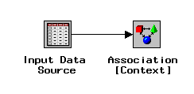
- Open the Input Data Source node.
- Select the BANK data set from the CRSSAMP library.
- Select the Variables tab.
- Set the model role for ACCT to id, for SERVICE to target, and for VISIT to sequence.
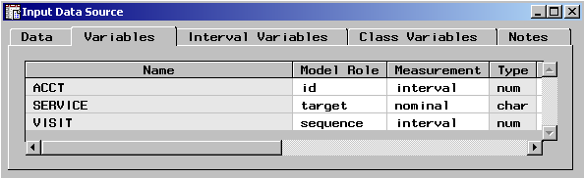
- Close and save changes to the Input Data Source node.
- Open the Association node. The Variables tab is active by default and lists the same information that is found in the Variables tab in the Input Data Source node.
- Select the General tab. This tab enables you to modify the analysis mode and control how many rules are generated.
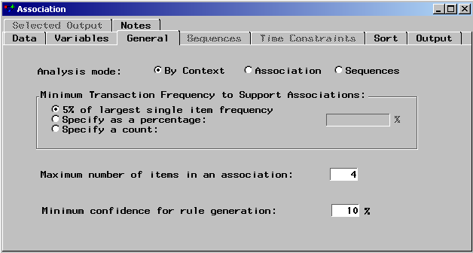
Inspect the Analysis mode options.
The default analysis mode is By Context. This mode uses information specified in the input data source to determine the appropriate analysis. If the input data set contains
- an ID variable and a target variable, the node automatically performs an association analysis
- a sequence variable that has a status of use, the node performs a sequence analysis.
Because there is a sequence variable in the input data set, the default analysis mode would be a sequence analysis. Sequence analysis is discussed later in this section, but for the moment, perform an association analysis.
- Change the Analysis mode to Association.
- Close the Association node, saving changes when prompted.
Other options include
- Minimum Transaction Frequency to Support Associations - specifies a minimum level of support to claim that items are associated (that is, they occur together in the database). The default frequency is 5%.
- Maximum number of items in an association - determines the maximum size of the item set to be considered. For example, the default of four items indicates that a maximum of 4 items will be included in a single association rule.
- Minimum confidence for rule generation - specifies the minimum confidence level to generate a rule. The default level is 10%. This option is grayed out if you are performing a sequence discovery.
- Run the diagram from the Association node and view the results. The Rules tab is displayed first.
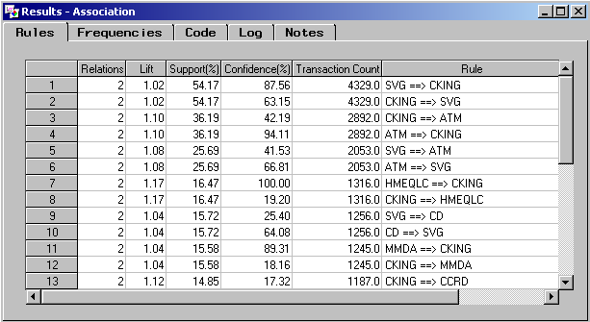
The Rules tab contains information for each rule. Consider the rule A ⇒ B. Recall that the
- support of A=>B is the probability that a customer has both A and B
- confidence of A=>B is the probability that a customer has B given that the customer has A.
- lift of A=>B is a measure of strength of the association. If the Lift=2 for the rule A=>B, then a customer having A is twice as likely to have B than a customer chosen at random.
- Right-click on the Support(%) column and select Sort ⇨ Descending.
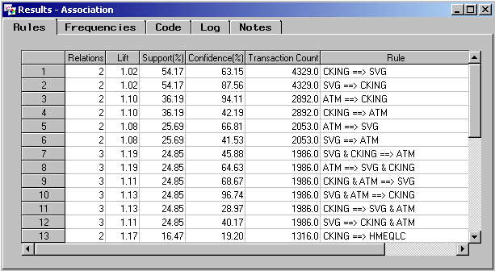
The support is the percentage of customers who have all the services involved in the rule. For example, approximately 54% of the 7,991 customers have a checking and savings account and approximately 25% have a checking account, savings account, and an ATM card.
- Right-click on the Confidence(%) column and select Sort ⇨ Descending.
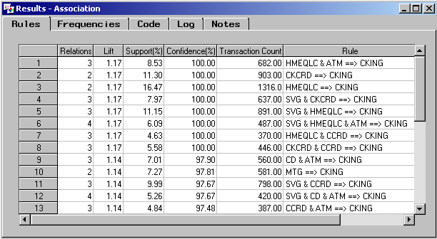
The confidence represents the percentage of customers who have the right-hand-side (RHS) item among those who have the left-hand-side (LHS) item. For example, all customers who have a checking account also have a check card. Among those customers that have both a savings account and a credit card, over 97% have a checking account.
- Right-click on the Lift column and select Sort ⇨ Descending.
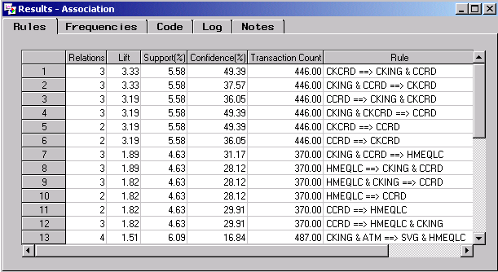
Lift, in the context of association rules, is the ratio of the confidence of a rule to the confidence of a rule assuming the RHS was independent of the LHS. Consequently, lift is a measure of association between the LHS and RHS of the rule. Values greater than 1 represent positive correlation between the LHS and RHS. Values equal to 1 represent independence. Values less than 1 represent negative correlation between the LHS and RHS.
The lift of the relationship CKCRD ==> CCRD is 3.19. Therefore, if you select a customer who has a check/debit card, the relative frequency of that customer having a credit card is more than 3 times higher than an individual chosen at random.
 By default, only rules with a lift greater than 1 are displayed in the results. You can change this by selecting View ⇨ When Confidence > Expected Confidence.
- Select the Frequencies tab.
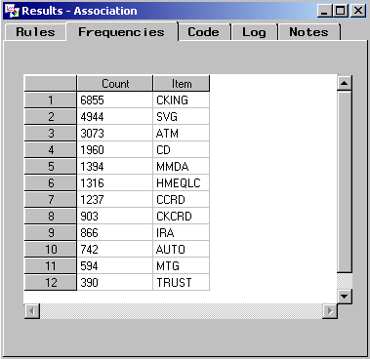
This tab shows the number of customers who have each of the products. This number is not the same as a simple frequency count. For example, a customer may have more than one checking account but is counted only once here.
This information can be important when trying to determine why a particular item did not appear in the rules. Recall that, by default, the minimum transaction frequency to support an association is 5% of the largest frequency item. In this case the largest frequency item is a checking account with a frequency of 6855. Therefore, if any group of products is not held by at least 343 customers (5% of 6855), they are not included together in a rule.
If you are interested in associations involving fairly rare products, you should consider reducing the minimum transaction frequency when you run the association node. If you obtain too many rules to be practically useful, you should consider raising the minimum transaction frequency as one possible solution.
Suppose you are particularly interested in looking at customers who have a money market deposit account (MMDA) and/or a certificate of deposit (CD) to determine what other types of products they also own.
- Select the Rules tab.
- Select View ⇨ Subset Table….
- In the Predecessor => Successor tab, control-click to select both CD and MMDA under Left Hand Side.
- In the drop-down menu for Type under Left Hand Side, select Combinations & Single.
- In the drop-down menu for Type under Right Hand Side, select Find Any.
- Select Process and examine the resulting table.
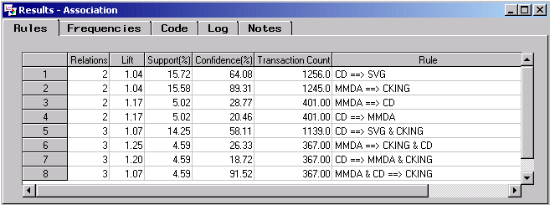
There are eight rules that contain MMDA, CD, or both on the left hand side.
Suppose instead that you are particularly interested in those associations that involve automobile loans. You would like to create a subset of the rules, to include only those rules with the product AUTO. The easiest way to accomplish this goal is to save the rules as a data set and then use a SAS Code node to subset that data.
- Select View ⇨ Reset Table.
- Select File ⇨ Save As Data Set….
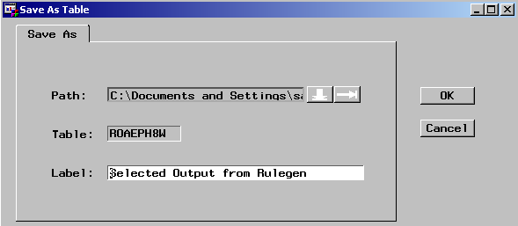
- Note that the data set will be saved with the label Selected Output from Rulegen. Select OK to save the data set.
- Close the Association node results window and add a SAS Code node to the diagram.
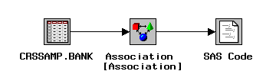
- Open the SAS Code node and select the Macros tab.
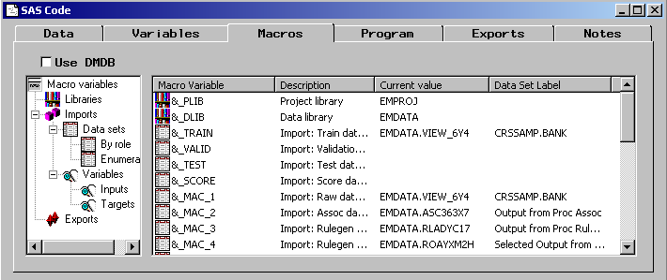
Enterprise Miner automatically creates many macro variables. In this case, note the variable &_MAC_4, which is the data set you saved from the Association node results.
- Select the Program tab.
- Type in the following program:
data work.auto;
set &_MAC_4;
if item1='AUTO' or item2='AUTO' or item3='AUTO'
or item4='AUTO' or item5='AUTO';
run;

proc print data=work.auto;
run;
- Select the Run SAS Code button, , to submit the program.
- Select Yes to run the SAS code now.
- Select Yes to view the results, when prompted.
- Select the Output tab.
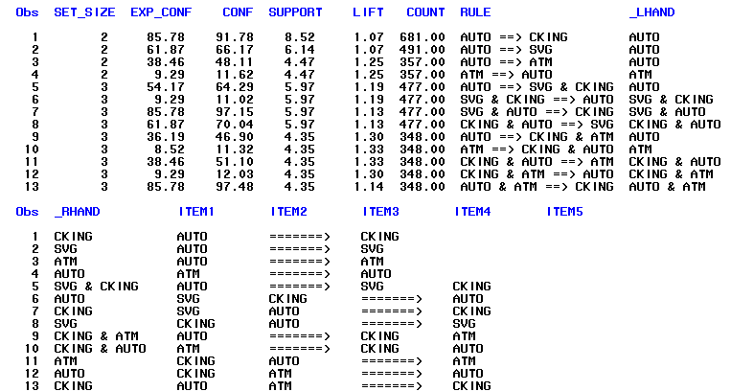
There are 13 rules that involve automobile loans as shown in the output.
- Close the SAS Code node results and the SAS code node when you are finished examining the output.
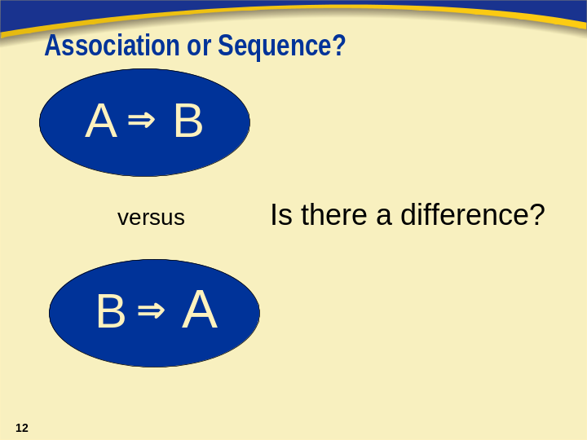
Association analysis is designed to determine the relationships between products offered for sale. In other words, what products are likely to appear together in a customer’s basket?
Sequence analysis takes this a step further in that it examines the order in which products are purchased. This can be helpful in answering such questions as: if a customer purchased product A this week, is he likely to purchase product B next week?
A sequence analysis requires the specification of a variable whose model role is sequence. An association analysis ignores a sequence variable.

Sequence Analysis

In addition to the products owned by its customers, the bank is interested in examining the order in which the products are purchased. The sequence variable in the data set allows you to conduct a sequence analysis.
- Add an Association node to the diagram workspace and connect it to the Input Data Source node.
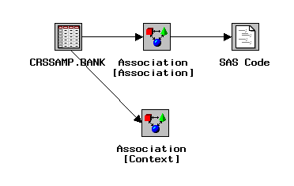
- Open the new Association node.
- Select the General tab. Note that because there is a sequence variable with a status of use in the input data set, by default, the analysis mode will be a sequence analysis.
- Select the Sequences tab.
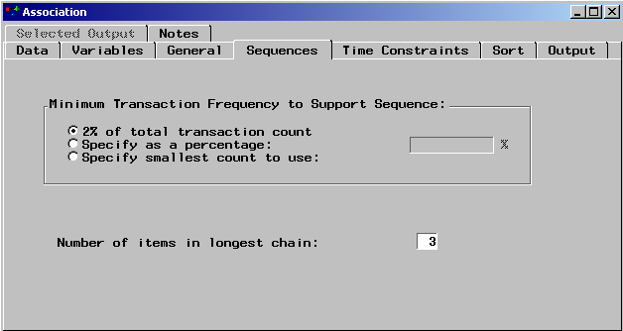
The options in the Sequences tab enable you to specify the minimum transaction frequency required to report a sequence and the total number of items that can be in the longest chain reported. The maximum number of items that can be specified is 10.
- Select the Time Constraints tab.
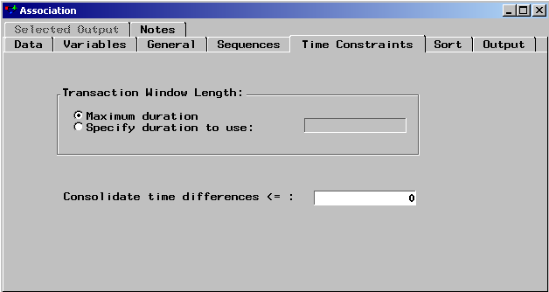
The options here allow you to specify the maximum length of time for a series of transactions to be considered a sequence. For example, you might want to specify that the purchase of two products more than three months apart from each other does not constitute a sequence.
Another option is to consolidate time differences. In other words, two products purchased less than a day apart from each other are actually the same transaction.
- Close the Association node, leaving the default settings.
- Run the diagram from the Association node and select Yes to view the results when prompted.
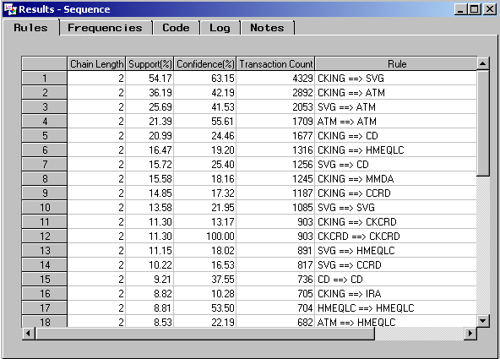
- Right-click on the Confidence(%) column and select Sort ⇨ Descending.
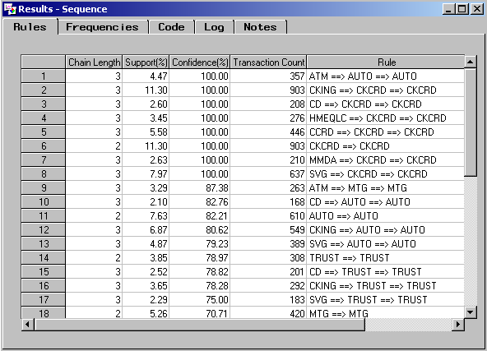
The transaction count is the total number of customers that have purchased products in this order. The percent support is the transaction count divided by the total number of customers, which would be the maximum transaction count. The percent confidence is the transaction count divided by the transaction count for the left side of the sequence (which can be determined by looking at the Frequencies tab). So, for example, of the customers that got an automobile loan, 82.21% got a second automobile loan.
Suppose you only want to see those sequences that involve automobile loans.
- Select View ⇨ Subset Table….
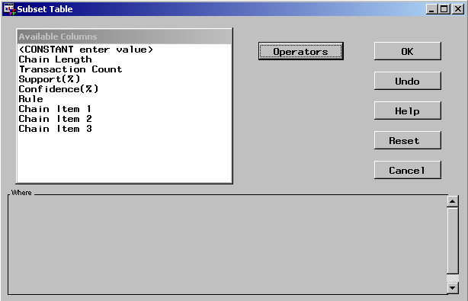
- From the Available Columns list, select Chain Item 1.
- From the Operators list, select EQ.
- From the Available Columns list, select <LOOKUP distinct values>.
- Select AUTO.
- Select Operators ⇨ OR.
- From the Available Columns list, select Chain Item 2.
- From the Operators list, select EQ.
- From the Available Columns list, select <LOOKUP distinct values>.
- Select AUTO.
- Select Operators ⇨ OR.
- From the Available Columns list, select Chain Item 3.
- From the Operators list, select EQ.
- From the Available Columns list, select <LOOKUP distinct values>.
- Select AUTO.
- Select OK.
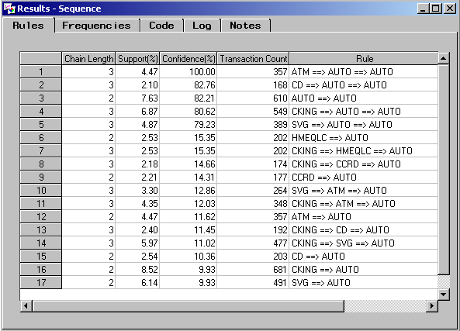
Seventeen rules involve automobile loans as shown above.
- Close the sequence analysis results when you are finished examining the output.

Dissociation Analysis (Self-Study)
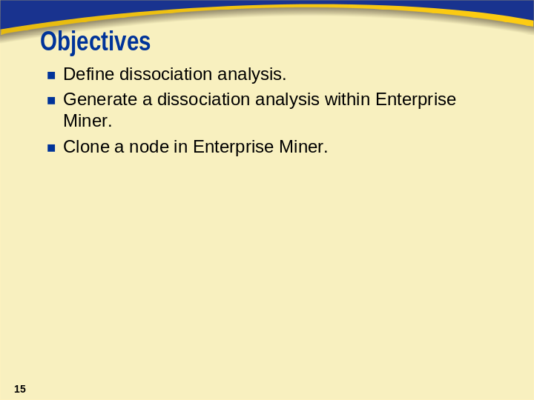
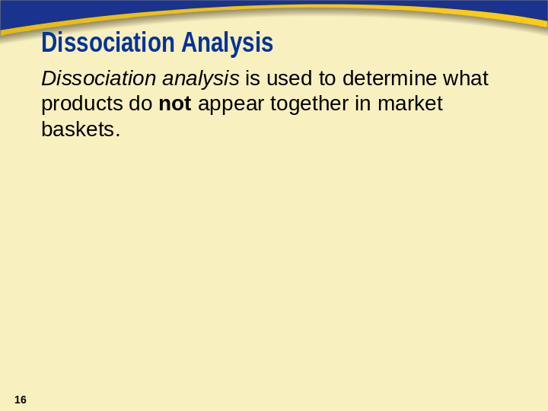
A dissociation rule is a rule involving the negation of some item. For example, the left side may represent no checking account (~CKING) and the right side might be an auto loan. In other words, customers who do not have checking accounts tend to have auto loans. Dissociation rules may be particularly interesting when the items involved are highly prevalent.

Dissociation Analysis

The Association node will include dissociation rules if the data is modified to include the negation of selected items. The SAS Code node can be used for such data modification.
Creating Dissociations
Augment the data with services not present in each account.
- Add a SAS Code node to the workspace and connect it to the Input Data Source node.
- Add another Association node to the diagram and connect it to the SAS Code node.
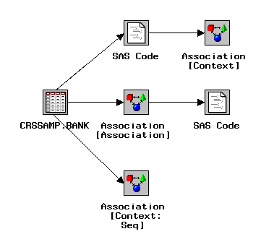
- Open the new SAS Code node.
- Select the Macros tab. Observe that the name of the training data set is &_TRAIN. As seen earlier, you can use the macro names in the programs used in this node. It is unnecessary to know the exact name that the Enterprise Miner has assigned to each data set.
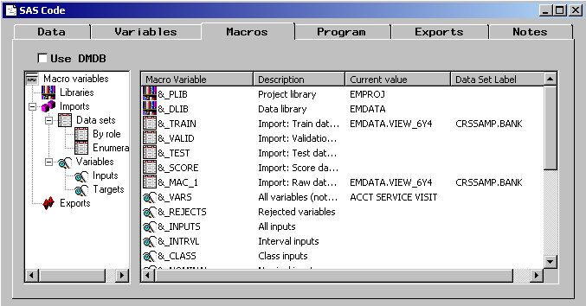
- Select the Exports tab.
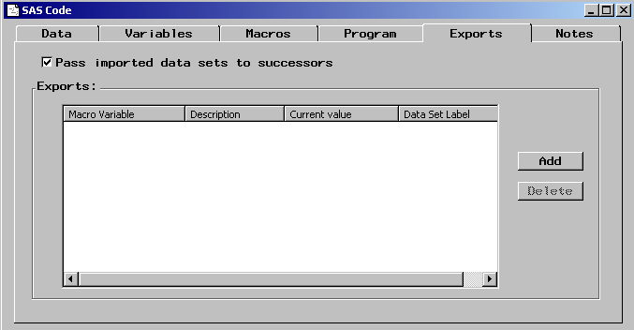
- Select Add.
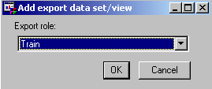
- Select OK to choose the training data for export. Note that the name of the data set is &_TRA.
- Deselect Pass imported data sets to successors.
- Select the Program tab.
- Select File ⇨ Import File and a browser opens. Use the browser to locate the program Dissoc.sas.
- Highlight the program Dissoc.sas.
- Select OK.
- Close the SAS code node and save changes when prompted.
- Rename the node in the diagram to SAS Code Dissociations.
Node Cloning
At this point, the SAS Code node can be used for dissociation analysis for any data set. If you anticipate doing more dissociation analyses, it would be helpful to save this code node with the other nodes in the Tools tab. By cloning a node, you can add it as a custom node to the tools palette. Clone the SAS Code node and add it to the Node types palette.
- Right-click on the SAS Code Dissociations node and select Clone….
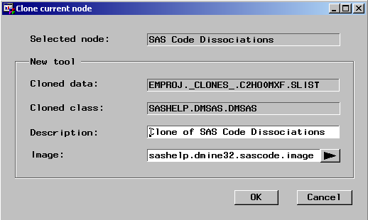
- Change the Description to Dissociations.
- Select the right arrow next to the Image field.
- Select an appropriate icon from the palette.
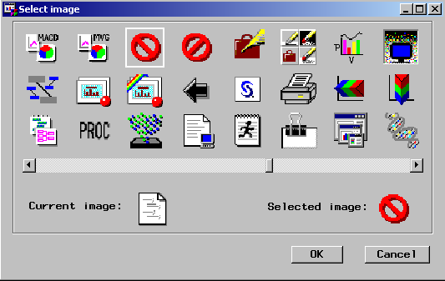
- Select OK to accept the image.
- Select OK to close the Clone Current Node window.
- Select the Tools tab from the left side of the Enterprise Miner application window. Scroll down to the bottom of the tools. A new tool appears at the bottom of the Tools palette with the icon you selected.
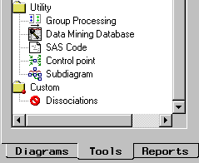
The cloned tool can be used in the diagram in place of the SAS Code node. A cloned tool is saved in the project library. Consequently, every diagram created within the project will have the Dissociations node available for use. Note that this cloned node has to be modified with variable and level names that are specific to the data set with which it will be used.
Modifying the Dissociations Node
- Open the SAS Code Dissociations node. The Program tab is active.
- Modify the first three lines of the imported program as shown below:
%let values=’SVG’,’CKING’,’MMDA’;
%let in=&_TRAIN;
%let out=&_TRA;
The first line identifies the values of the target for which negations are created. The values must be enclosed in quotes and separated by commas. This program scans each ID (ACCT) to see if the items (services) specified in the values are present. If not, the data is augmented with the negated items. In this case you will create negations only for savings accounts, checking accounts, and money market accounts.
The second and third lines provide macro names for the training data and the augmented (exported) data.
- Close the SAS Code Dissociations node and save the changes.
- Run the diagram from the SAS Code Dissociations node, but do not view the results.
- Open the Association node.
- Select the Data tab.
- Select Properties… and then select the Table View tab. The listing is of the augmented data that was exported from the SAS Code node.
- Close the Association node.
- Run the Association node and view the results.
 Because the sequence variable was not passed to the new Association node by the SAS Code Dissociations node, the default analysis will be an association analysis rather than a sequence analysis. This is appropriate because there is no sequence to not purchasing a product.
The results now list association and dissociation rules. For example, among customers without a money market account, 65.58% have a savings account (rule 4).
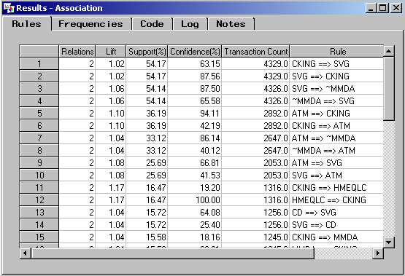
Close the Association node when you have finished examining the results.

